**CS 5590BD LAB -3 REPORT**

Submitted by Saikiran Pasala

Student id: 16154892

* Installed Glassfish server and it is started successfully.

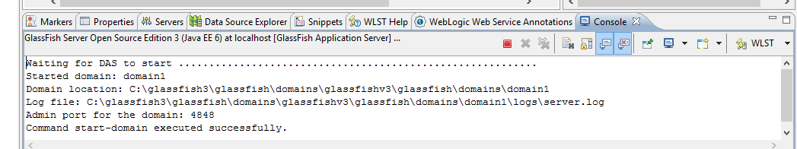

* Upload the glassfishv3.zip to the cloudera and then unzip it and start the domain.

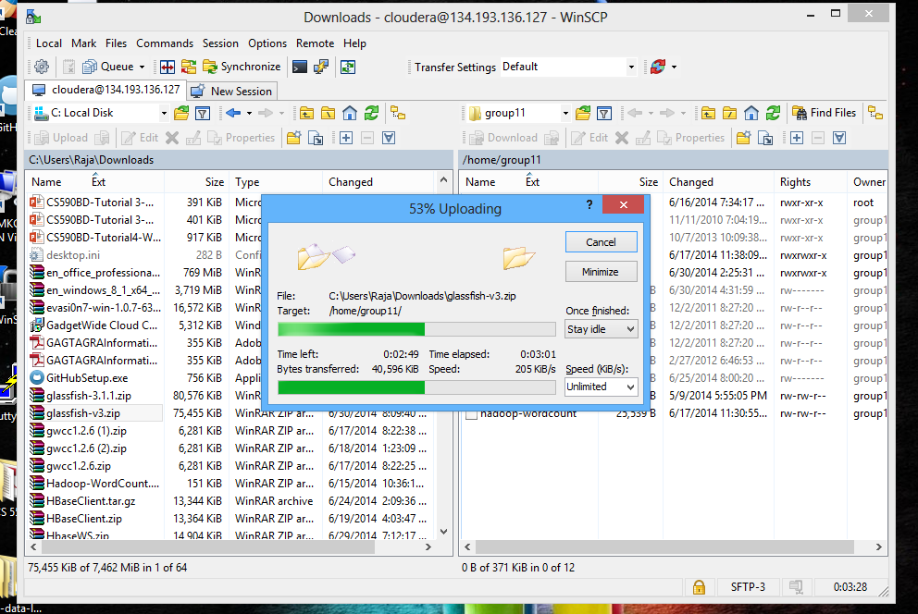

* Create a dynamic web project .

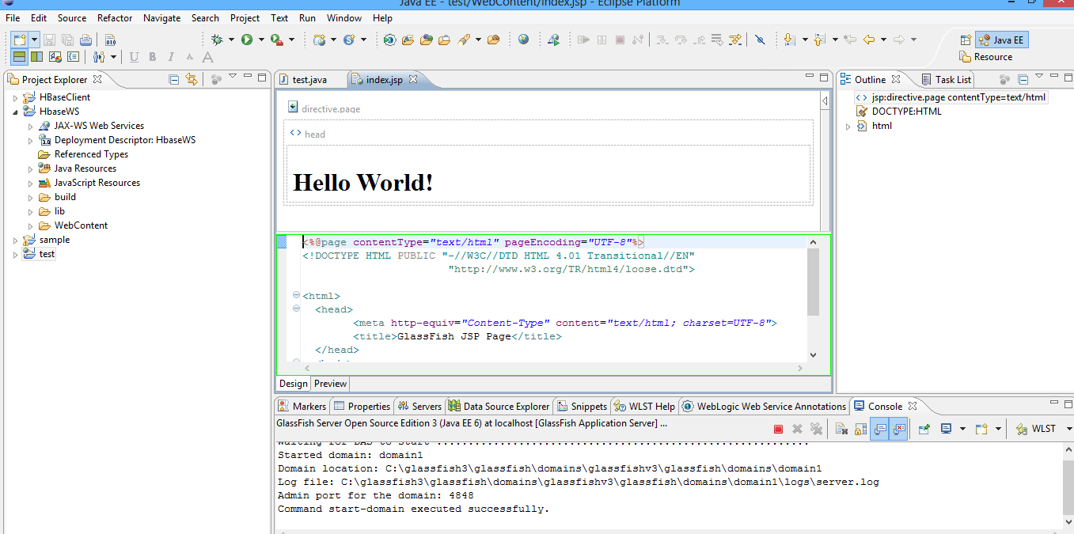

* Create a restful web service

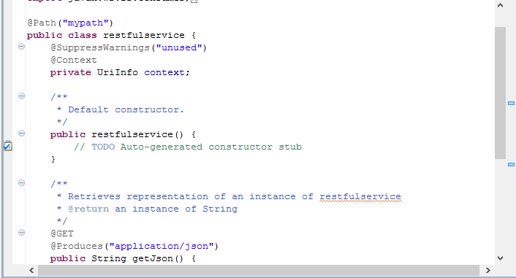

* Make changes to the code and then generate a war file and Include jar file into WAR
* Perform the create table, insert table and retrieve table on hbase using this war